Net4Mobility

Mid Term Review
NCP Forum
9-10-(11) June 2016
Geneva,Switzerland

Venue – Geneva

HOTEL
NH Geneva Airport
Av. De Mategnin 21
1211 Geneva-Meyrin 1
www.nh-hotels.com
+41 22 98 99 506

Since the hotels in Geneva are expensive, we booked one hotel close to the airport in the middle of the 2 events places.
In order to book your room, please complete the following document www.net4mobility.eu/fileadmin/NhHotalRegistrationFormularyEuresearch.doc and send it to nhgenevaairport@nh-hotels.com
Inform them also about the transfer from the airport to the hotel. The hotel will come and pick you up at the airport.

Thursday 9 June 2016
CERN – IDEASQUARE
European Organization for Nuclear Research
1211 Genève 23
Switzerland

Friday 10 June 2016:
Campus Biotech
9 Chemin des Mines
1202 Genève

Agenda Thursday 9 June 2016
Training & Best Practice Seminar
When | What | Who
08:00 | Meeting in NH Lobby to go to the CERN
8:30-9:00 | Welcome & Coffee
09:00 – 09:15 | Welcome and Seminar Overview | Jennifer
09:15 – 09:45 | Brainstorming! What are the challenges of working with the Non-Academic (NA) Sector? | Jennifer & Task Supporting Partners | Group Exercise
09:45 – 10:45 | Presentations of Best Practices by NCPs | 1) Jennifer  2) Grace  3) Jesús | Presentation
09:00 – 09:15 | Welcome and Seminar Overview | Jennifer
 | Coffee Break
11:10 – 11:45 | “Flash” Presentations by NCPs – experiences with NA Sector | Pierantonios  Dalibor  Juliane  Hanna  Marlis | 5-minute oral presentations
11:45 – 12:45 | Role Play | Jennifer & Task Supporting Partners | Exercise in Pairs
12:45 – 13:00 | Wrap-up & feed-back questionnaire | Jennifer
11:10 – 11:45 | “Flash” Presentations by NCPs – experiences with NA Sector | Pierantonios  Dalibor  Juliane  Hanna  Marlis | 5-minute oral presentations
11:45 – 12:45 | Role Play | Jennifer & Task Supporting Partners | Exercise in Pairs
12:45 – 13:00 | Wrap-up & feed-back questionnaire | Jennifer | 12:45 – 13:00
13:00-15:00 | Lunch+ Visit CERN
15:00-17:30 | Training: Project Management  (by Tubitak) | All MSCA NCP
20:30 | Networking Dinner @ NH Hotel | All MSCA NCP

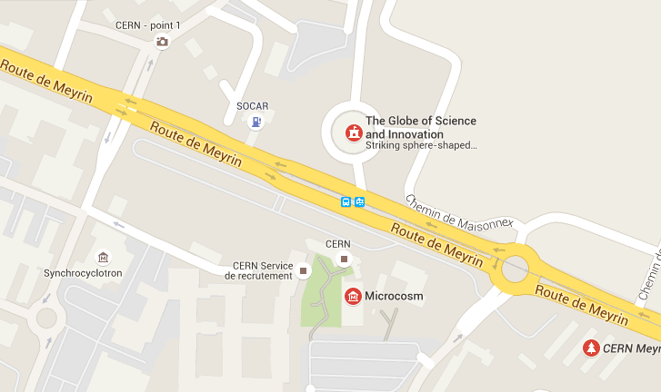

Agenda Friday 10 June 2016
NCP Forum + Mid Term Review
Venue: Biotech Campus

When | What | Who
Meeting 8:15 in the Hotel Lobby for charter to the Biotech Campus
NCP Forum
9:00-9:30 | Welcome & Coffee
9.40-11:00 | World Coffee  20 minutes per World Coffee  5 minutes presentation by WP Leaders + 15 minutes discussion with the different groups on the outcomes.  Ice-breaking Questions:  Were you aware about the outcomes of the work package?  Do you use them and how?  Do they have an impact on your NCP work?  What are your recommendation /ideas/inputs for the future of the work package? |  | Net4Mobility WP Leaders
Mid Term Review
11:00-11:15 | Opening – Official Welcome  Adoption of the Agenda | Juliane Sauer, Coordinator Net4Mobility
 | ADD MARIA!!!!
11:15-11:45 | Presentation of the Mid Term Review Report | Juliane Sauer
11:45-12:30 | Tour de table from WP Leaders on the main successes or problems they faced for the implementation of the project | WP Leaders
12:30-13:30 | Lunch
13:30-14:30 | Continuation of the tour de table | WP Leaders
14:30-15:00 | Budget Financial Issue | Véronique Sordet
15:00-15:30 | Coffee Break
15:30-16:00 | Recommendations for improvements | Seamus Hegarty,  reviewer Net4Mobility, CERN  Maria Tsivertara, EC Project Officer
16:00-16:30 | Open Discussions | All
16:30 | End of the day
17:00-  19:00 | Steering Committee | Steering Committee Net4Mobility

Agenda Saturday 11 June 2016
Social Activity: Visit United Nation and Red Cross Museum
When | What | Where | Price
9:00 | Meeting at Hotel Lobby and departure for UN Visit | Hotel NH | -
10:00-11:00 | Visit United Nation “Palais des Nations” | Visitor’s Entrance “Pregny Gate”, 14 Avenue de la Paix – 1211 Geneva | 10 CHF (around 8 euro per person) ) – NOT PAID BY THE PROJECT
11:30-12:30 | Visit Red Cross Museum | Musée internationale de la Croix Rouge  Avenue de la Paix 17 – 1211 Geneva | 16 CHF (around 14 euros per person) – NOT PAID BY THE PROJECT

How to reach what
From the airport to the NH Hotel
The NH Geneva Airport hotel provides free shuttle-bus service to the hotel every 20 minutes from 5:50 am to 11:40 pm. Please ask while booking
More info: http://www.nh-hotels.com/hotel/nh-geneva-airport/map?_ga=1.35436706.225406701.1452607968

From NH Hotel to CERN
Take the no. 14 tram (direction CERN) from Jardin Alpin (5 minutes on foot from the hotel) – it only takes 5 minutes and a free transport ticket can be asked at the Hotel.

From NH Hotel to City Centre
Take tram no. 14 (direction P+R Bernex) or the 18 (direction Carouge) from Jardin Alpin (5 minutes on foot from the hotel). They both go to the city centre via Gare Cornavin railway station. It takes about 15 minutes and costs 3 CHF (buy your ticket at the stop before boarding).

Practical Info about Switzerland

BUSINESS HOURS
Most institutions are open from Monday to Friday 9:00-18:30. Shops are open also on Saturday. Only a very few shops are open on Sunday.

MEALS
Most of your meals will be provided as part of the program.

CLIMATE
Switzerland climates can be changing in June. Check the meteo: http://www.meteosuisse.admin.ch/
Warm casual clothes are recommended for traveling and informal wear is acceptable in most places.

LANGUAGE
Switzerland: French, German and Italian are the national official languages while English is widely spoken and understood in major cities but French is the main language in Geneva.

CURRENCY
Swiss Francs is the Swiss Currency. Bank notes are in 10, 20, 50, 100, 200, and 1000 CHF and coins in 0.05, 0.10, 0.20, 0.50, 1, 2, 5 CHF. Currently, it has an exchange rate of approx. 1.20 CHF = 1 Euro

MEDICATIONS
Please bring a supply of any necessary medications with you. However, there is a medical & first aid centre at Geneva Main Station and airport.

ELECTRICITY
Swiss outlets are not the same as the rest of Europe. Please bring a universal adaptor with you (the one from PeopleNetwork+ ;o)

SMOKING
By Swiss Government policy, smoking is not permitted inside any public air-conditioned buildings. Additionally, the rooms reserved at the Hotel are non-smoking. Smokers are asked to smoke outside in the open-air area.

Emergency Contact Information

Juliane Sauer
juliane.sauer@euresearch.ch
0041 79 396 36 85 (mobile)

Véronique Sordet
Veronique.sordet@euresearch.ch
0041 79 374 97 28 (mobile)

